LET’S LEARN ABOUT

[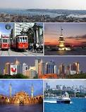](http://www.google.com.tr/imgres?q=%C4%B0STANBUL&start=112&hl=tr&biw=1280&bih=598&tbm=isch&tbnid=y8oKiTkaAcD4mM:&imgrefurl=https://tr.wikipedia.org/wiki/%C4%B0stanbul&docid=q0cuHxiAgEgckM&imgurl=https://upload.wikimedia.org/wikipedia/commons/thumb/f/f2/Istanbul_collage_5555.jpg/280px-Istanbul_collage_5555.jpg&w=280&h=368&ei=eAKWUZDpG4_ltQbWsYHABg&zoom=1&iact=rc&dur=250&page=6&tbnh=138&tbnw=105&ndsp=24&ved=1t:429,r:23,s:100,i:73&tx=24&ty=76)[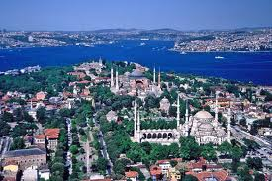](http://www.google.com.tr/imgres?q=%C4%B0STANBUL&start=136&hl=tr&biw=1280&bih=598&tbm=isch&tbnid=xhYicCSBV3uWnM:&imgrefurl=http://www.uydutr.com/topografya/istanbul&docid=wKv9s13vAx1i6M&imgurl=http://www.uydutr.com/harita/resim/istanbul1.jpg&w=500&h=333&ei=eAKWUZDpG4_ltQbWsYHABg&zoom=1&iact=rc&dur=109&page=7&tbnh=137&tbnw=217&ndsp=24&ved=1t:429,r:53,s:100,i:163&tx=78&ty=48)

ISTANBUL

ISTANBUL FENERBAHÇE ANADOLU LİSESİ

ISTANBUL COMENIUS MEETING

21-24 MAY 2013-02-06 JUNE 2013

[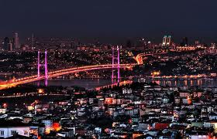](http://www.google.com.tr/imgres?q=%C4%B0STANBUL&start=112&hl=tr&biw=1280&bih=598&tbm=isch&tbnid=txISKKqokomcGM:&imgrefurl=http://www.liderlikokulu.com.tr/liderlik-okulu-istanbul/&docid=yw8MXhUctkVlCM&imgurl=http://www.liderlikokulu.com.tr/site/dosyalar/Liderlik-Okulu-%25C4%25B0stanbul.jpg&w=630&h=404&ei=eAKWUZDpG4_ltQbWsYHABg&zoom=1&iact=rc&dur=124&page=6&tbnh=146&tbnw=240&ndsp=24&ved=1t:429,r:16,s:100,i:52&tx=79&ty=89)

**Istanbul** (Turkish: *İstanbul*) is the largest city in Turkey, constituting the country's economic, cultural, and historical heart. With a population of 13.9 million, the city forms one of the largest urban agglomerations in Europe and is among the largest cities in the world by population within city limits. Istanbul's vast area of 5,343 square kilometers (2,063 sq mi) is coterminous with Istanbul Province, of which the city is the administrative capital. Istanbul is a transcontinental city, straddling the Bosphorus—one of the world's busiest waterways—in northwestern Turkey, between the Sea of Marmara and the Black Sea. Its commercial and historical center lies in Europe, while a third of its population lives in Asia.

[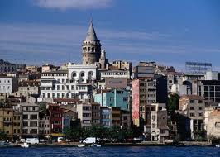](http://www.google.com.tr/imgres?q=%C4%B0STANBUL&start=112&hl=tr&biw=1280&bih=598&tbm=isch&tbnid=YS03JKFUWiisdM:&imgrefurl=http://tr.hotels.com/de1341107-st1/istanbul-turkiye-bir-y-ld-zl-oteller/&docid=PjEtzVXH-ze8DM&imgurl=http://a2.cdn-hotels.com/static/common/23.0/images/photos/city/1341107_Istanbul_Turkey.jpg&w=518&h=370&ei=eAKWUZDpG4_ltQbWsYHABg&zoom=1&iact=hc&vpx=887&vpy=164&dur=670&hovh=190&hovw=266&tx=142&ty=107&page=6&tbnh=138&tbnw=192&ndsp=24&ved=1t:429,r:22,s:100,i:70)

Founded on the Sarayburnu promontory around 660 BC as Byzantium, the city now known as Istanbul developed to become one of the most significant cities in history. For nearly sixteen centuries following its reestablishment as Constantinople in 330 AD, it served as the capital of four empires: the Roman Empire (330–395), the Byzantine Empire (395–1204 and 1261–1453), the Latin Empire (1204–1261), and the Ottoman Empire (1453–1922). It was instrumental in the advancement of Christianity during Roman and Byzantine times, before the Ottomans conquered the city in 1453 and transformed it into an Islamic stronghold and the seat of the last caliphate. Although the Republic of Turkey established its capital in Ankara, palaces and imperial mosques still line Istanbul's hills as visible reminders of the city's previous central role.

Istanbul's strategic position along the historic Silk Road rail networks to Europe and the Middle East, and the only sea route between the Black Sea and the Mediterranean have helped foster an eclectic populace, although less so since the establishment of the Republic in 1923. Overlooked for the new capital during the interwar period, the city has since regained much of its prominence. The population of the city has increased tenfold since the 1950s, as migrants from across Anatolia have flocked to the metropolis and city limits have expanded to accommodate the Arts festivals were established at the end of the 20th century, while infrastructure improvements have produced a complex transportation network.

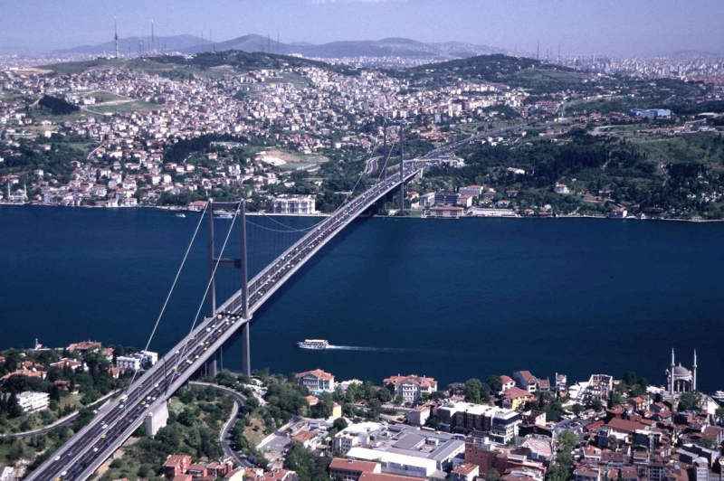

11.6 million foreign visitors arrived in Istanbul in 2012, making the city the world's fifth-most-popular tourist destination. The city's biggest draw remains its historic center, partially listed as a UNESCO World Heritage Site, but its cultural and entertainment hub can be found across the city's natural harbor, the Golden Horn, in the Beyoğlu district. Considered a global city, Istanbul is one of the major and fastest-growing metropolitan economies in the world . It hosts the headquarters of many Turkish companies and media outlets and accounts for more than a quarter of the country's gross domestic product.] Hoping to capitalize on its revitalization and rapid expansion, Istanbul is currently bidding for the 2020 Summer Olympics.

The first known name of the city is *Byzantium* (Greek: Βυζάντιον, *Byzántion*), originating from the name of the king, Byzas, whose colony founded it around 660 BC. After Constantine the Great made it the new eastern capital of the Roman Empire in 330 AD, the city became widely known as *Constantinopolis* (Constantinople), which, as the Latinized form of "Κωνσταντινούπολις" (*Konstantinoúpolis*), means the "City of Constantine". He also attempted to promote the name *Nea Roma* ("New Rome"), but this did not attain widespread usage. *Constantinople* remained the most common name for the city in the West until the establishment of the Turkish Republic, and *Kostantiniyye* (Ottoman Turkish قسطنطينيه) was the primary name used by the Ottomans during their rule.

[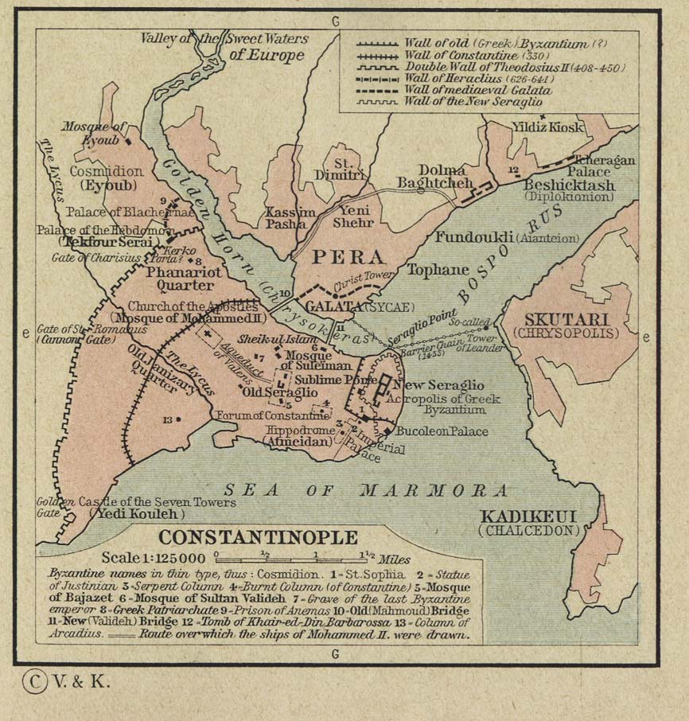](http://www.zonu.com/detail-en/2009-09-18-10149/Constantinople-Istanbul-Map.html)

By the 19th century, the city had acquired a number of other names used by either foreigners or Turks. Europeans used *Constantinople* to refer to the whole of the city, but used the name *Stamboul*—as the Turks also did—to describe the walled peninsula between the Golden Horn and the Sea of Marmara. *Pera* (from the Greek word for "across") was used to describe the area between the Golden Horn and the Bosphorus, but Turks also used the name *Beyoğlu*, which is still in use today. *Islambol* (meaning either "City of Islam" or "Full of Islam") was sometimes colloquially used to refer to the city, and was even engraved on some Ottoman coins, but the belief that it was the precursor to the present name, *İstanbul*, is belied by the fact that the latter existed well before the former and even predates the Ottoman and Muslim conquest of the city.

**HISTORY OF THE CITY**

Neolithic artifacts, dating back to the 7th millennium BC and uncovered by archaeologists at the beginning of the 21st century AD, indicate Istanbul's historic peninsula was settled earlier than previously thought. That settlement, important in the spread of the Neolithic Revolution from the Near East to Europe, lasted for almost a millennium before being inundated with the filling of the Bosphorus. Before the discovery, conventional wisdom held that Thracian tribes, including the Phrygians, began settling on the Sarayburnu in the late 6th millennium BC. On the Asian side, artifacts originating around the 4th millennium BC have been found in Fikirtepe (within Kadıköy). The same location was the site of a Phoenician trading post at the beginning of the 1st millennium BC as well as the town of Chalcedon, which was established around 680 BC.

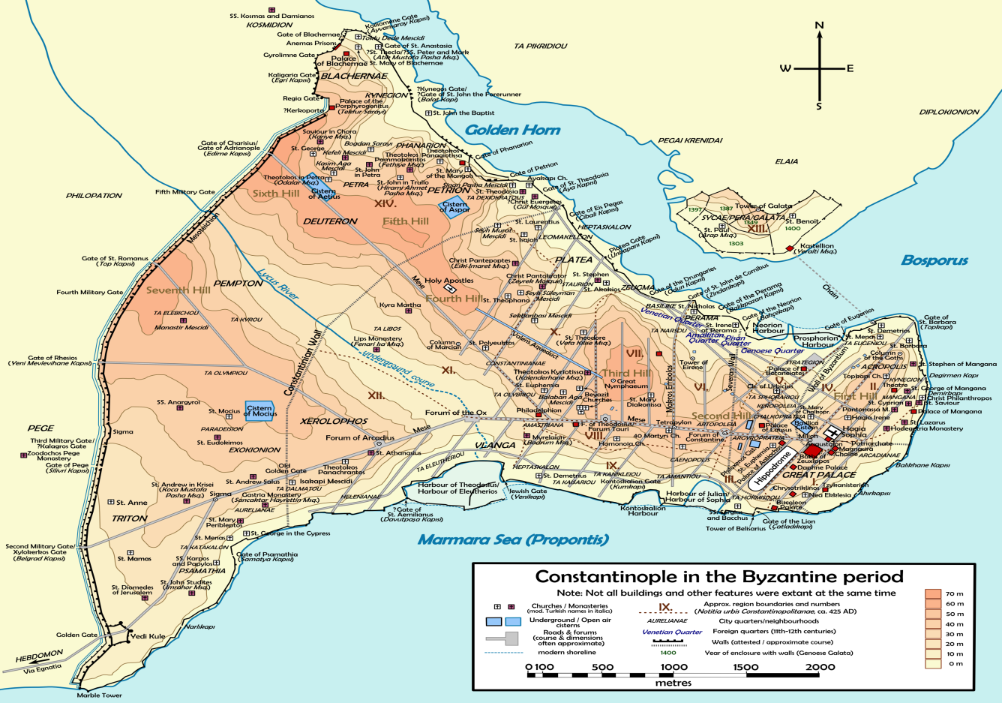

However, the history of Istanbul generally begins around 660 BC, when settlers from Megara, under the command of King Byzas, established Byzantium on the European side of the Bosphorus. The settlers proceeded to build an acropolis adjacent to the Golden Horn on the site of the early Thracian settlements, fueling the nascent city's economy. The city experienced a brief period of Persian rule at the turn of the 5th century BC, but the Greeks recaptured it during the Greco-Persian Wars. Byzantium then continued as part of the Athenian League and its successor, the Second Athenian Empire, before ultimately gaining independence in 355 BC. Long allied with the Romans, Byzantium officially became a part of the Roman Empire in 73 Ad. Byzantium's decision to side with the usurper Pescennius Niger against Roman Emperor Septimius Severus cost it dearly; by the time it surrendered at the end of 195 AD, two years of siege had left the city devastated . Still, five years later, Severus began to rebuild Byzantium, and the city regained—and, by some accounts, surpassed—its previous prosperity.

**CONSTANTINOPLE-THE OLD NAME OF THE CITY-**

Constantine the Great effectively became the emperor of the whole of the Roman Empire in September 324. Two months later, Constantine laid out the plans for a new, Christian city to replace Byzantium. As the eastern capital of the empire, the city was named *Nea Roma*; however, most simply called it Constantinople, a name that persisted into the 20th century. Six years later, on 11 May 330, Constantinople was proclaimed the capital of an empire that eventually became known as the Byzantine Empire or Eastern Roman Empire.

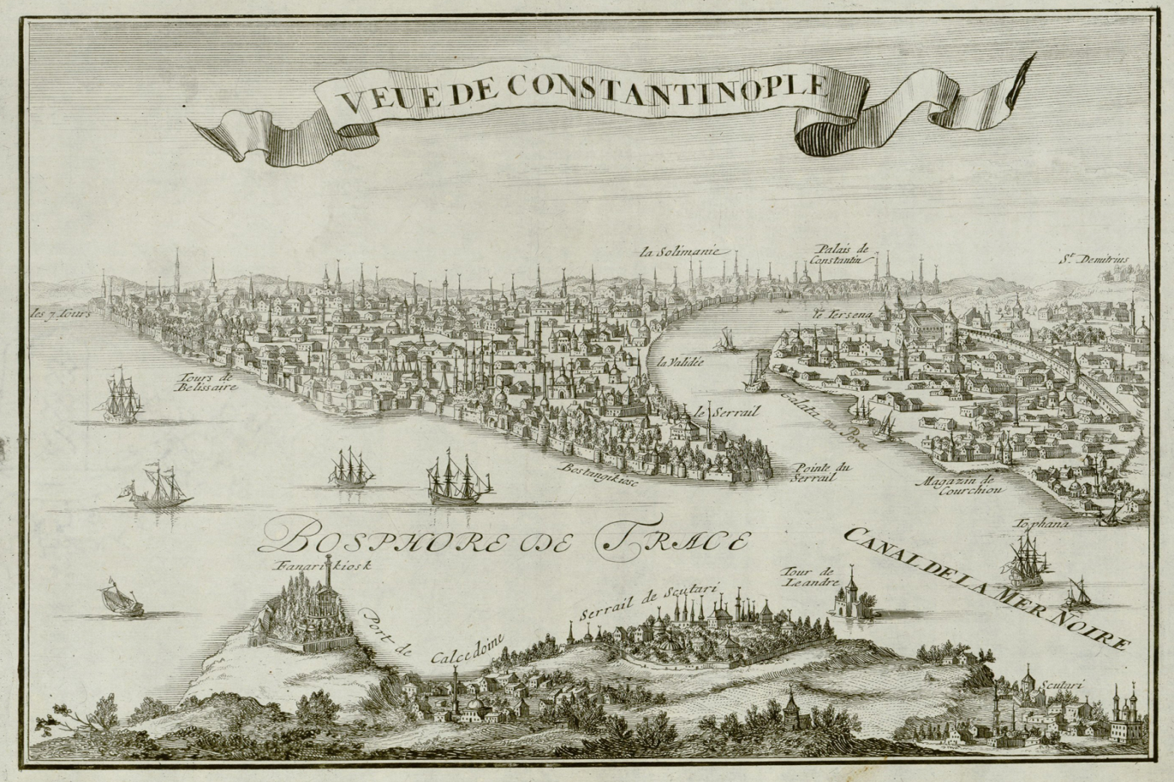

The establishment of Constantinople served as one of Constantine's most lasting accomplishments, shifting Roman power eastward as the city became a center of Greek culture and Christianity. Numerous churches were built across the city, including the Hagia Sophia, which remained the world's largest cathedral for a thousand years. Other improvements to the city undertaken by Constantine included a major renovation and expansion of the Hippodrome of Constantinople; accommodating tens of thousands of spectators, the hippodrome became central to civic life and, in the 5th and 6th centuries, the epicenter of episodes of unrest, including the Nika riots. Constantinople's location also ensured its existence would stand the test of time; for many centuries, its walls and seafront protected Europe against invaders from the east and the advance of Islam. During most of the Middle Ages, the latter part of the Byzantine era, Constantinople was the largest and wealthiest city on the European continent and at times the largest in the world.

Constantinople began to decline after the Fourth Crusade, during which it was sacked and pillaged. The city subsequently became the center of the Latin Empire, created by Catholic crusaders to replace the Orthodox Byzantine Empire. However, the Latin Empire was short-lived, and the Byzantine Empire was restored, albeit weakened, in 1261. Constantinople's churches, defenses, and basic services were in disrepair,[ and its population had dwindled to a hundred thousand from up to half a million during the 8th century.[[e]](https://en.wikipedia.org/wiki/Istanbul#cite_note-pop-figures-55)

[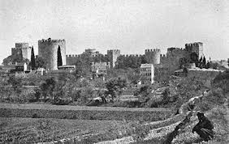](http://www.google.com.tr/imgres?q=constantinople&sa=X&hl=tr&biw=1280&bih=598&tbm=isch&tbnid=7BHHpVLGRUk9OM:&imgrefurl=http://www.kidspast.com/world-history/0143-constantinople.php&docid=kNYh1A9HLdCSlM&imgurl=http://www.kidspast.com/images/constantinople.jpg&w=400&h=253&ei=5QSWUbaRA8fZtQbWgYGYAg&zoom=1&iact=hc&vpx=426&vpy=165&dur=3214&hovh=178&hovw=282&tx=108&ty=104&page=2&tbnh=136&tbnw=227&start=19&ndsp=26&ved=1t:429,r:34,s:0,i:266)

Various economic and military policies instituted by Andronikos II, such as the reduction of military forces, weakened the empire and left it more vulnerable to attack. In the mid-14th century, the Ottoman Turks began a strategy of taking smaller towns and cities over time, cutting off Constantinople's supply routes and strangling it slowly. Finally, on 29 May 1453, after an eight-week siege (during which the last Roman emperor, Constantine XI, was killed), Sultan Mehmed II "the Conqueror" captured Constantinople and declared it the new capital of the Ottoman Empire. Hours later, the sultan rode to the Hagia Sophia and summoned an imam to proclaim the Islamic creed, converting the grand cathedral into an imperial mosque.

**THE ERA AFTER THE ROMAN EMPIRE**

**OTTOMAN AND TURKISH ERA**

Following the fall of Constantinople, Mehmed II immediately set out to revitalize the city, by then also known as Istanbul. He urged the return of those who had fled the city during the siege, and forcibly resettled Muslims, Jews, and Christians from other parts of Anatolia. The sultan invited people from all over Europe to his capital, creating a cosmopolitan society that persisted through much of the Ottoman period. Meanwhile, Mehmed II repaired the city's damaged infrastructure, began to build the Grand Bazaar, and constructed Topkapı Palace, the sultan's official residence.

[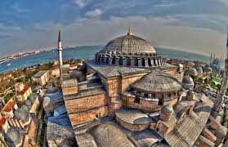](http://www.google.com.tr/imgres?q=%C4%B0STANBUL&start=232&hl=tr&biw=1280&bih=598&tbm=isch&tbnid=2Lt5yaPtuEq71M:&imgrefurl=http://www.ekofinans.com/turizmde-avrupa-birincisi-istanbul-h23483.html&docid=w0eIMaMZwfQomM&imgurl=http://www.ekofinans.com/application/static/data/611x395_istanbul_5156a2895e824.jpg&w=611&h=395&ei=MwSWUdqjEofmtQbBkYCQBg&zoom=1&iact=hc&vpx=163&vpy=165&dur=702&hovh=180&hovw=279&tx=78&ty=101&page=11&tbnh=142&tbnw=208&ndsp=23&ved=1t:429,r:39,s:200,i:121)

The Ottomans quickly transformed the city from a bastion of Christianity to a symbol of Islamic culture. Religious foundations were established to fund the construction of grand imperial mosques, often adjoined by schools, hospitals, and public baths. The Ottoman Dynasty claimed the status of caliphate in 1517, with Istanbul remaining the capital of this last caliphate for four centuries. Suleiman the Magnificent's reign from 1520 to 1566 was a period of especially great artistic and architectural achievement; chief architect Mimar Sinan designed several iconic buildings in the city, while Ottoman arts of ceramics, calligraphy, and miniature flourished. The total population of Istanbul amounted to 570,000 by the end of the 18th century.

In the early 20th century, the Young Turk Revolution disposed of Sultan Abdul Hamid II and a series of wars plagued the ailing empire's capital. The last of these, World War I, resulted in the British, French, and Italian occupation of Istanbul. The final Ottoman sultan, Mehmed VI, was exiled in November 1922; the following year, the occupation of Istanbul ended with the signing of the Treaty of Lausanne and the recognition of the Republic of Turkey, declared by Mustafa Kemal Atatürk.

[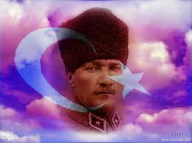](http://www.google.com.tr/imgres?q=atat%C3%BCrk&start=174&hl=tr&biw=1280&bih=598&tbm=isch&tbnid=EwQTz-GAlFl0EM:&imgrefurl=http://ataturkresimleri.biz/bayrak-ataturk-resimleri-5/&docid=ZmOORNNhJNAelM&imgurl=http://ataturkresimleri.biz/images/bayrak-ataturk-resimleri--5.jpeg&w=1033&h=773&ei=lQmWUf3KJ8antAbZ4YCoCQ&zoom=1&iact=rc&dur=140&page=7&tbnh=140&tbnw=166&ndsp=24&ved=1t:429,r:74,s:100,i:226&tx=91&ty=76)

In the early years of the republic, Istanbul was overlooked in favor of Ankara, selected as Turkey's capital to distance the new, secular country from its Ottoman history. However, starting from the late 1940s and early 1950s, Istanbul underwent great structural change, as new public squares, boulevards, and avenues were constructed throughout the city, sometimes at the expense of historical buildings. The population of Istanbul began to rapidly increase in the 1970s, as people from Anatolia migrated to the city to find employment in the many new factories that were built on the outskirts of the sprawling metropolis. This sudden, sharp rise in the city's population caused a large demand for housing development, and many previously outlying villages and forests became engulfed into the metropolitan area of Istanbul.

**GEOGRAPHY**

Istanbul is located in northwestern Turkey within the Marmara Region on a total area of 5,343 square kilometers (2,063 sq mi). The Bosphorus, which connects the Sea of Marmara to the Black Sea, divides the city into a European, Thracian side—comprising the historic and economic centers—and an Asian, Anatolian side. The city is further divided by the Golden Horn, a natural harbor bounding the peninsula where the former Byzantium and Constantinople were founded. The confluence of the Sea of Marmara, the Bosphorus, and the Golden Horn at the heart of present-day Istanbul has deterred attacking forces for thousands of years and still remains a prominent feature of the city's landscape.

Following the model of Rome, the historic peninsula is said to be characterized by seven hills, each topped by imperial mosques. The easternmost of these hills is the site of Topkapı Palace on the Sarayburnu. Rising from the opposite side of the Golden Horn is another, conical hill, where the modern Beyoğlu district is situated. Because of the topography, buildings in Beyoğlu were once constructed with the help of terraced retaining walls, and roads were laid out in the form of steps. Üsküdar on the Asian side exhibits similarly hilly characteristics, with the terrain gradually extending down to the Bosphorus coast, but the landscape in Şemsipaşa and Ayazma is more abrupt, akin to a promontory. The highest point in Istanbul is Çamlıca Hill, with an altitude of 288 meters (945 ft).[[72]](https://en.wikipedia.org/wiki/Istanbul#cite_note-topo-77)

**CITYSCAPE**

The Fatih district corresponds to what was, until the Ottoman conquest, the whole of the city, across from which stood the Genoese citadel of Galata. Those Genoese fortifications were largely demolisHed in the 19th century, leaving only the Galata Tower, to make way for northward expansion of the city. Galata is now a part of the Beyoğlu district, which forms Istanbul's commercial and entertainment center around Taksim Square.

**[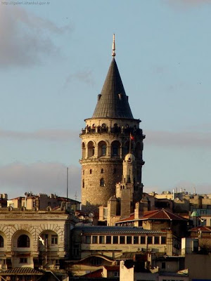](http://3.bp.blogspot.com/-9FVm_287_Zk/UPBfGV6T4MI/AAAAAAAAAF8/o14lcJdPy2A/s1600/GALATA4.jpg)**

Dolmabahçe Palace, the seat of government during the late Ottoman period, is located The former village of Ortaköy is situated within Beşiktaş and provides its name to the Ortaköy Mosque, along the Bosphorus near the First Bosphorus Bridge. Lining the shores of the Bosphorus north of there are *yalıs*, luxurious chalet mansions originally built by 19th-century aristocrats and elites as summer homes. Farther inland, outside the city's inner ring road, are Levent and Maslak, Istanbul's primary economic centers.

**ARCHITECTURE OF ISTANBUL FROM ROMAN EMPIRE**

Istanbul is primarily known for its Byzantine and Ottoman architecture, but its buildings reflect the various peoples and empires that have previously ruled the city. Examples of Genoese and Roman architecture remain visible in Istanbul alongside their Ottoman counterparts. While nothing of the architecture of the classical Greek period has survived, Roman architecture has proved to be more durable. Obelisks from the Hippodrome of Constantinople are still visible in Sultanahmet Square, while a section of the Valens Aqueduct, constructed in the late 4th century, stands relatively intact at the western edge of the Fatih district. The Column of Constantine, erected in 330 AD to mark the new Roman capital, still stands not far from the Hippodrome.

[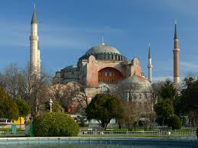](http://www.google.com.tr/imgres?q=bizans+mimarisi+istanbul&hl=tr&biw=1280&bih=598&tbm=isch&tbnid=3V_P1kh3D2xUkM:&imgrefurl=http://odogan.com/havadan-sudan/ayasofya-tarihi-ayasofya-mimari-ozellikleri.html&docid=Ly_3MXPkEJW6bM&imgurl=http://odogan.com/wp-content/uploads/2010/07/AyaSofya.jpg&w=1152&h=864&ei=8B6WUfPFIYPBtQaCxYGQCg&zoom=1&iact=rc&dur=109&page=3&tbnh=146&tbnw=180&start=44&ndsp=26&ved=1t:429,r:46,s:0,i:222&tx=66&ty=107)

Hagi Sophia

Early Byzantine architecture followed the classical Roman model of domes and arches, but improved upon these elements, as in the Church of the Saints Sergius and Bacchus. The oldest surviving Byzantine church in Istanbul—albeit in ruins—is the Monastery of Stoudios (later converted into the Imrahor Mosque), which was built in 454. After the recapture of Constantinople in 1261, the Byzantines enlarged two of the most important churches still extant, Chora Church and Pammakaristos Church. Still, the pinnacle of Byzantine architecture, and one of Istanbul's most iconic structures, is the Hagia Sophia. Topped by a dome 31 meters (102 ft) in diameter, the Hagia Sophia stood as the world's largest cathedral for more than a thousand years, before being converted into a mosque and, as it stands now, a museum.

[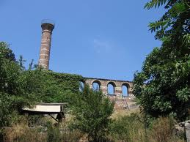](http://www.google.com.tr/imgres?q=imrahor+camii&hl=tr&biw=1280&bih=598&tbm=isch&tbnid=lemB-hmT8aX9JM:&imgrefurl=http://www.geolocation.ws/v/P/36929450/mrahor-camii-former-monastery-of/en&docid=fvLEi7-cXQ5Z6M&imgurl=http://commondatastorage.googleapis.com/static.panoramio.com/photos/original/36929450.jpg&w=1408&h=1056&ei=GCGWUcGDOYHdswaU7YH4DQ&zoom=1&iact=hc&vpx=254&vpy=26&dur=1450&hovh=194&hovw=259&tx=146&ty=129&page=2&tbnh=138&tbnw=183&start=15&ndsp=23&ved=1t:429,r:16,s:0,i:164) [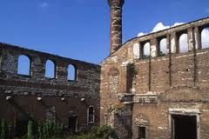](http://www.google.com.tr/imgres?q=imrahor+camii&hl=tr&biw=1280&bih=598&tbm=isch&tbnid=KhsW54_VeKbKjM:&imgrefurl=http://www.istanbul.net.tr/istanbul-Rehberi/istanbul-muzeleri/imrahor-aniti-ilyas-bey-camii-st-studios-manastiri-hagios-ionnes-prodromos-bazilikasi/78/4&docid=W9mM4tF8NWQyIM&imgurl=http://istanbul.net.tr/Uploads/img12/istanbul-rehberi/muze/%25C4%25B0mrahor-An%25C4%25B1t%25C4%25B1.jpg&w=300&h=200&ei=GCGWUcGDOYHdswaU7YH4DQ&zoom=1&iact=hc&vpx=585&vpy=35&dur=2028&hovh=160&hovw=240&tx=84&ty=66&page=3&tbnh=130&tbnw=206&start=38&ndsp=27&ved=1t:429,r:41,s:0,i:244)

The oldest church in Istanbul ( Monastery of Stoudious)

**CULTURE OF ISTANBUL**

İstanbul was historically known as a cultural hub, but its cultural scene stagnated after the Turkish Republic shifted its focus toward Ankara. The new national government established programs that served to orient Turks toward musical traditions, especially those originating in Europe, but musical institutions and visits by foreign classical artists were primarily centered in the new capital. Although much of Turkey's cultural scene had its roots in Istanbul, it was not until the 1980s and 1990s that Istanbul reemerged globally as a city whose cultural significance is not solely based on its past glory.

By the end of the 19th century, Istanbul had established itself as a regional artistic center, with Turkish, European, and Middle Eastern artists flocking to the city. Despite efforts to make Ankara Turkey's cultural heart, Istanbul had the country's primary institution of art until the 1970s. Furthermore, when additional universities and art journals were founded in Istanbul during the 1980s, artists formerly based in Ankara moved in.Beyoğlu has been transformed into the artistic center of the city, with young artists and older Turkish artists formerly residing abroad finding footing there. Modern art museums, including İstanbul Modern, the Pera Museum, Sakıp Sabancı Museum and SantralIstanbul, opened in the 2000s to complement the exhibition spaces and auction houses that have already contributed to the cosmopolitan nature of the city. Still, these museums have yet to attain the popularity of older museums on the historic peninsula, including the Istanbul Archaeology Museums, which ushered in the era of modern museums in Turkey, and the Turkish and Islamic Arts Museum.

Coinciding with this cultural reemergence was the establishment of the Istanbul Festival, which began showcasing a variety of art from Turkey and around the world in 1973. From this flagship festival came the International Istanbul Film Festival and the Istanbul International Jazz Festival in the early 1980s. With its focus now solely on music and dance, the Istanbul Festival has been known as the Istanbul International Music Festival since 1994.. The most prominent of the festivals that evolved from the original Istanbul Festival is the Istanbul Biennial, held every two years since 1987. While its early incarnations were aimed at showcasing Turkish visual art, it has since opened to international artists and risen in prestige to become among the elite biennales, alongside the Venice Biennale and the São Paulo Art Biennial.

**HISTORICAL SHOPPING CENTERS IN İSTANBUL**

Istanbul has numerous shopping centers, from the historic to the modern. The Grand Bazaar, in operation since 1461, is among the world's oldest and largest covered markets. Mahmutpasha Bazaar is an open-air market extending between the Grand Bazaar and the Egyptian Bazaar, which has been Istanbul's major spice market since 1660.

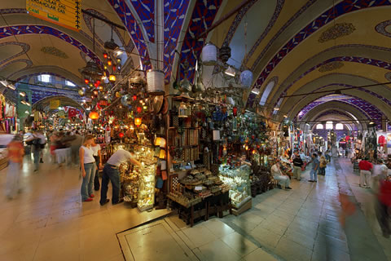

Grand Bazaar (Covered Bazaar)

**WHAT TO EAT AND DRINK IN İSTANBUL**

Aside from typical Turkish cuisine like kebab, Istanbul is also famous for its historic seafood restaurants. Many of the city's most popular and upscale seafood restaurants line the shores of the Bosphorus, while the Kumkapı neighborhood along the Sea of Marmara has a pedestrian zone that hosts around fifty fish restaurants. The Princes' Islands, 15 kilometers (9 mi) from the city center, are also popular for their seafood restaurants. Because of their restaurants, historic summer mansions, and tranquil, car-free streets, the Princes' Islands are a popular vacation destination among Istanbulites and foreign tourists.

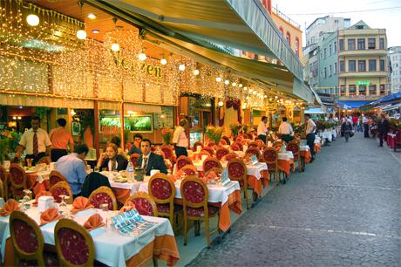

**EDUCATION IN ISTANBUL**

İstanbul University, founded in 1453, is the oldest Turkish educational institution in the city. Although originally an Islamic school, the university established law, medicine, and science departments in the 19th century and was secularized after the founding of the Turkish Republic. Istanbul Technical University, founded in 1773 as the Royal School of Naval Engineering, is the world's third-oldest university dedicated entirely to engineering sciences. These public universities are two of just eight across the city; other prominent state universities in Istanbul include the Mimar Sinan Fine Arts University, which served as Turkey's primary institution of art until the 1970s, and Marmara University, the country's third-largest institution of higher learning. Istanbul Medeniyet University, founded in 2010, is the newest public university, offering two-year degrees through eleven academic departments.

While the most established universities in Istanbul are backed by the government, the city has a number of prominent private institutions. The first modern private university in Istanbul, also the oldest American school still in existence in its original location outside the United States, was Robert College, founded by Christopher Robert, a wealthy American and a philanthropist, and Cyrus Hamlin, a missionary devoted to education, in 1863. The tertiary element of its education program has become the public Boğaziçi University in 1971, while the remaining portion in Arnavutköy continues as a boarding high-school under the name Robert College.

Galatasaray High School, established in 1481 as the Galata Palace Imperial School, is the oldest high school in Istanbul and the second-oldest educational institution in the city. It was built at the behest of Sultan Bayezid II, who sought to bring students with diverse backgrounds together as a means of further strengthening his growing empire. It is one of Turkey's Anatolian High Schools, elite public high schools that place a stronger emphasis on instruction in foreign languages. Galatasaray, for example, offers instruction in French, while other Anatolian High Schools primarily teach in English or German alongside Turkish. The city also has foreign high schools, such as Liceo Italiano, that were established in the 19th century to educate foreigners.

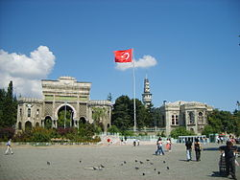

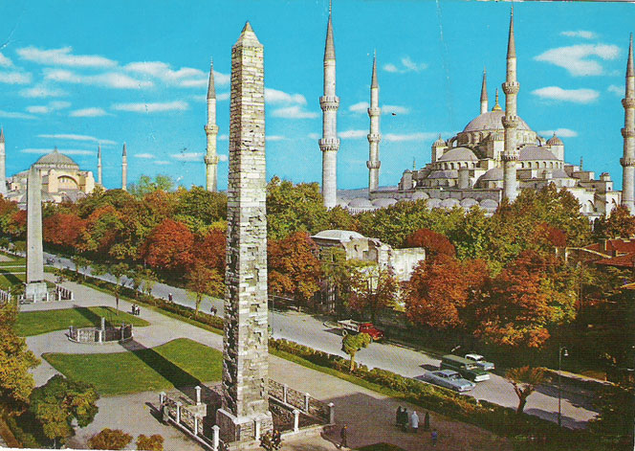

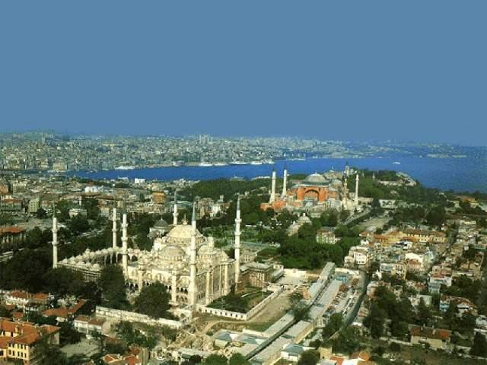

[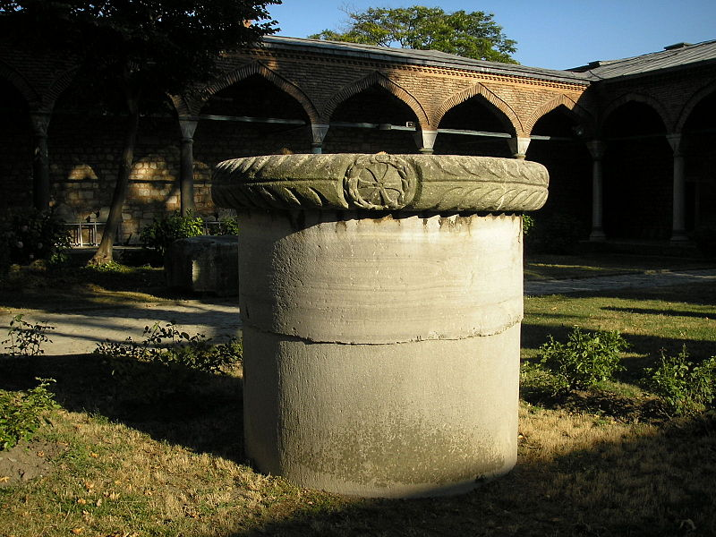](https://upload.wikimedia.org/wikipedia/commons/b/b3/Second_Court_Topkapi_2007_80.JPG)

[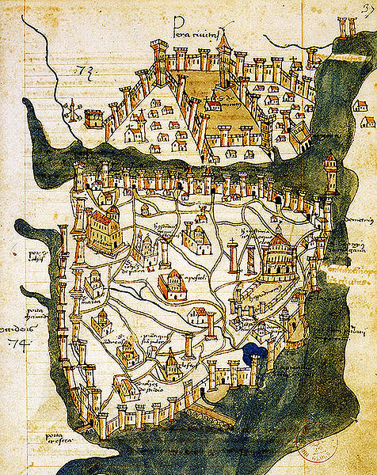](https://upload.wikimedia.org/wikipedia/commons/9/91/Map_of_Constantinople_(1422)_by_Florentine_cartographer_Cristoforo_Buondelmonte.jpg)

[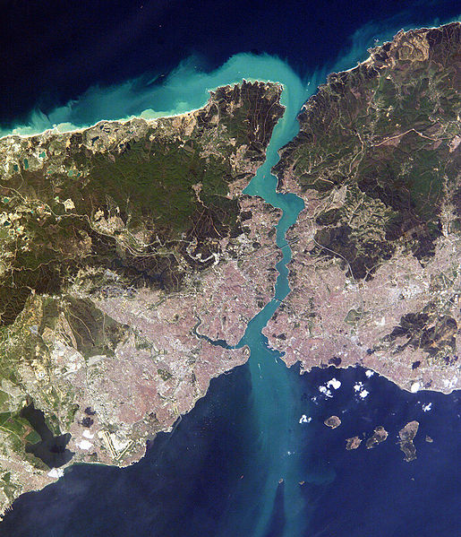](https://upload.wikimedia.org/wikipedia/commons/e/e4/Istambul_and_Bosporus_big.jpg)